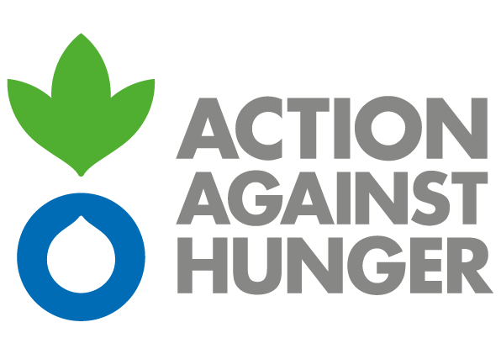 | Action Against Hunger  Mission Sudan

ADVERTISEMENT

EMERGENCY ASSISTANCE TO THE MOST VULNERABLE POPULATION IN CENTRAL DARFUR AND WIGHT NILE STATE, SOUTH KORDOFAN STATE AND BLUE NILE STATE

PD: (SD-KH00111), PD:(SD-KH00112), PD: (SD-KH00115)

Action Against Hunger tackles the causes and effects of hunger and diseases that threaten the lives of vulnerable children, women, and men.
Established in France in 1979, Action Against Hunger are a nongovernmental, non-political, non-religious, non-profit organisation.

Action Against Hunger - Sudan intends to award a Contracts for the (Hygiene kit -PD no SD KH 00111) , (Dignity Kit-PD no SD KH 00112) and ( Upgrading Handpump to Solar Tender PD no SD KH 00115) in the framework of humanitarian programs funded by GFFO.

Bidding documents can be obtained by interested parties from:

Mohamed Uthman, Logistics Officer.
Tel: +249 (0) 917266966, email: mumuhammed@sd.acfspain.org

or downloaded directly at the end of this advertisement.

Offers shall be sent exclusively to the following email addresses, following the instructions in the Request for Quotation from.
To: mumuhammed@sd.acfspain.org
CC:procurement-sd@sd.acfspain.org

The deadline for submission of tenders is December 14^{th and} 16th, 2021 at 14pm (Khartoum time). You can see the closing in each tender dossier

Action Against Hunger does not bind itself to award the tender to the lowest offer or any bid and reserves the right to accept the whole or part of the tender

